**SMILE DETECTION**

***A PROJECT REPORT***

***Submitted in partial fulfilment of the requirement for the award of the degree***

***of***

**MASTER’S IN DATA SCIENCE**

**In course**

**MACHINE LEARNING DTSC 710, CSCI 860)**

***by***

**MEHREET SINGH BAJAJ (1274698)**

**Callyn Villanueva (1257192)**

**Xiangkun Hu (1258111)**

**Chenyue Zhang (1271671)**



**DECLARATION**

**We hereby declare that the projects entitled “SMILE DETECTION” submitted as part of the partial course requirements for the course *MACHINE LEARNING (Group - Project)* , for the award of the degree of Masters in Data Science at New York Institute of Technology during the 2nd semester, has been carried out by us as a group . We declare that the project has not formed the basis for the award of any degree, associate ship, fellowship or any other similar titles elsewhere.**

**Further, we declare that we will not share, re-submit or publish the code, idea, framework and/or any publication that may arise out of this work for academic or profit purposes without obtaining the prior written consent of the Course Faculty Mentor and Course Instructor.**

**Signature of the Students:**

**MEHREET SINGH BAJAJ (1274698)**

**CHENYUE ZHANG (1271671)**

**XIANGKUN HU (1258111)**

**CALLYN VILLANUEVA (1257192)**

**Place: New York Institute of Technology**

**Date: 12.22.2020**

**CERTIFICATE**

**This is to certify that the projects entitled “ SMILE DETECTION" is a record of bonafide work carried out as part of the course *MACHINE LEARNING (Group - Project)*, under my guidance by *Mehreet Singh Bajaj (1274698)* , *Chenyue Zhang (1271671), Xiangkun Hu (1258111) and Callyn Villanueva (1257192)* during the academic semester *2nd*, in partial fulfilment of the requirements for the award of the Degree of Masters in Data Science, at New York Institute of Technology during academic year 2020.**

**Xueqing Huang**

**Project guide**

**New York Institute of Technology**

**ACKNOWLEDGEMENT**

**We as a group wish to express our deep sense of gratitude to our guide Xueqing Huang, Professor, Computer and Data Science department, New York Institute of Technology for her guidance and useful suggestions, for encouraging us to work on this project, using the techniques taught in the class and implementing them for real case scenarios, without which it would’ve been impossible to complete this project, that too in time. We are really thankful to her for believing in me and my project idea and helping us in shaping it up even better than we thought we could.**

**We feel blessed to have each other as a group of friends with the same thinking and different ideologies which helped us in shaping the project perfectly in a fun and learning way. It was due to the intellectual discussion that we had with each other all the time that always motivated us and inspired us to do something, that we collaborated together and came up with the willingness to do these projects.**

**MEHREET SINGH BAJAJ (1274698)**

**CHENYUE ZHANG (1271671)**

**XIANGKUN HU (1258111)**

**CALLYN VILLANUEVA (1257192)**

**MACHINE LEARNING 2020**

**ABSTRACT**

**PROJECT** : **SMILE DETECTION**

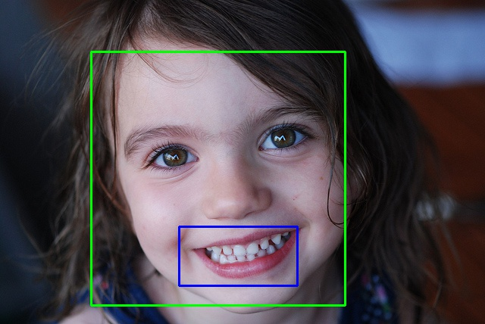

Smile detection from facial images is a specialized task in facial expression analysis with many potential applications such as smiling payment, patient monitoring and photo selection (Zhang et. al 2015). In this project, we propose to use Haar cascades; a machine learning object detection algorithm used to identify objects in an image or video based upon peer review study "Rapid Object Detection using a Boosted Cascade of Simple Features" (2001) [1]. With the help of computer systems, the tasks of figuring out expressions and the reasons behind it become easier. Machine learning is used in order to study the complicated reasons behind human emotions and figure out the secret behind human emotions.

|  |
| --- |
| **TABLE OF CONTENTS** |

*Cover Page* ………………………………………………………………………………...

*Declaration*…………………………………………………………………………………

*Certificate...*………………………………………………………………………………...

*Acknowledgement* ………………………………………………………………………….

*Abstract*………………………… ………………………………………………………….

*Table of contents* ……………….…………………………………………………………

**1.** **Introduction ……………………………………………………………………….………**

1.1. Basic Introduction…………………...………………………………...…………

**2. Requirement Analysis ……………………………………………………………………**

Functional Requirements…………………………………………………….…….…

**3.Background Analysis…………….. ....……………………………………………..…**

Overview………………………………………………………………………..

Methodology ………………………………………………………………................

**4. Experiment ……………………………………………………………………………..**

**5. Analysis ……….……..……....…………………………………………………………**

**6.Conclusion……………………………………………………………………………..**

**7. References………………………………………………………………………………**

**INTRODUCTION**

A simple smile might just be more than a chemical reaction. A smiling customer is more likely to walk through the door again, and data on smiles can help businesses understand which products would do better and have a higher retention rate.

Machines can learn to recognize happiness and smile and in this report, we are going to show how to create a smile recognition model that can do so.

Facial expressions are the expressions that appear on a human's faces in response to a person’s real internal emotions. With the evolution of social society and emerging numbers of cameras, it is important to massively analyze the pictures and content captured by monitors and social media. It helps people to understand the science behind it through deciphering the pictures and analyze the pixels behind it. The goal is to let computers automatically analyze and recognize facial motions and facial feature changes from the pictures captured. Sometimes people are not aware of the difference between the facial expression analysis and emotion analysis in the computer vision domain. [2] In short, emotion analysis is a higher field. Interpretation is normally aided by context, body gesture, voice, individual differences, and cultural factors as well as by facial configuration. [3] The study of facial expressions is also used in different fields, such as psychological studies, human movement analysis, face detection, face tracking, and recognition make the automatic facial expression analysis.

**REQUIREMENT ANALYSIS**

**2.1 Functional Requirements**

Providing the details of the project, all requirements and specifications will be made. Some of the functionalities we are going to use in our project are the basic principles of Data science and Deep learning techniques along with Python. Smile detection using Machine Learning and its tactical implementation has been shown. Most of the important libraries of python have been implemented in our code in the best possible way to enhance the quality of our project.

All the work has been done in the python 3 environment of jupyter notebook using base language as Python. This provides a better work environment and faster run time than other IDE available out there .

**BACKGROUND ANALYSIS**

**3.1Overview**

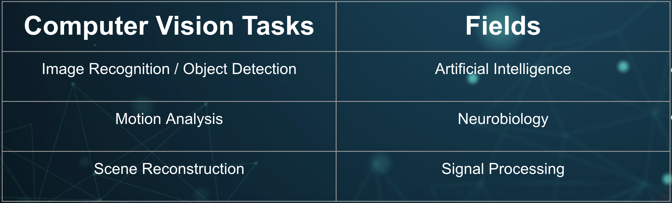

**3.2Methodology**

In our project, we implement the haar-feature based cascade classifier, which is a widely used image process algorithm, to perform the smile detection. This classifier was first proposed by Paul Viola and Micheal Jones in their paper, “Rapid Object Detection using a Boosted Cascade of Simple Features” in 2001.

As it is named, cascade classifier is a concatenate of several sub-classifiers. The sub-classifiers will be separated into several stages or layers, similar to the Convolutional Neural Network, the output of the previous stage will be the input of the next layer. Different from the other classifiers, the cascade classifier is not aiming to combine several strong classifiers, even this sounds very powerful, it is a concatenation of lots of weak learners. By combining all these weak learners, the cascade classifier can become a strong learner that performs good.

The cascade classifier is also a machine learning based classification system that we have to train it with a huge amount of positive images, which contains the target we want to classifier, and negative images, which contains nothing we wanted. After training, it then can be used in classification to detect certain objects in the other images. However, just like all the other machine learning based classifiers, cascade classifiers also have to be worried about the size of the training dataset and the overfitting or underfitting problem. But fortunately, The haar-feature based cascade classifier we implemented here can automatically extract the haar-feature, which is a less sensitive feature, to perform the training.

The Haar feature, or so called haar-wavelet, was proposed by Alfred Haar in 1909. It is simply a rectangle that is separated by white, black and grey.

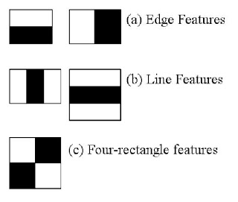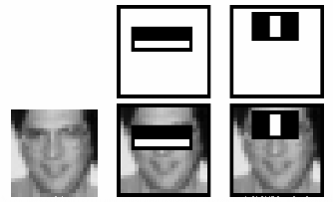

Figure 1: Haar-feature Figure 2: Feature example

Just like what shows in the figure 1, this is how the Haar-feature looks like. When the face image in figure 2 appears in the training set, the computer will assign a number for each pixel depending on how white this pixel is. It is easy to find out that the eye sector is much darker than the cheek sector, and that is where the first feature comes out. Similarly, the upper nose sector is lighter than the eye sector beside it, therefore the second feature can be extracted. After the testing process, if these two features also did a good job to classify other images, they will be signed as strong features and be used in the future classifications.

Let me assume that the value assigned in each pixel will be between 0 and 1.

|  |  |  |  |
| --- | --- | --- | --- |
| 0 | 0 | 1 | 1 |
| 0 | 0 | 1 | 1 |
| 0 | 0 | 1 | 1 |

Table 1

|  |  |  |  |
| --- | --- | --- | --- |
| 0.1 | 0.2 | 0.8 | 0.8 |
| 0.3 | 0.3 | 0.6 | 0.8 |
| 0.1 | 0.2 | 0.7 | 0.6 |

Table 2

The table 1 will be the ideal case of the Haar-feature that clearly shows white and black.

And the table 2 is not that perfect, but we still can distinguish the left part is lighter and the right side is darker. There is a formula that:

**W = Average of dark - Average of white**

W stands for the weight of this feature. In table 1, the ideal case, the W is simply equal to 1, and in table 2, the non-perfect case, the W = 0.52, which means that this case is not a very good one for classification. It is easy to find out that when W is close to 1, it is easier to find the borderline of dark site and white side, which means the computer found a Haar-feature and the larger the W is, the better this haar-feature is. In addition, in the real world example, the value of each pixel will definitely be more complicated than this, therefore the W and the borderline will become much more flexible and unpredictable, which makes this algorithm more useful.

**3.3 Schematic of Program**

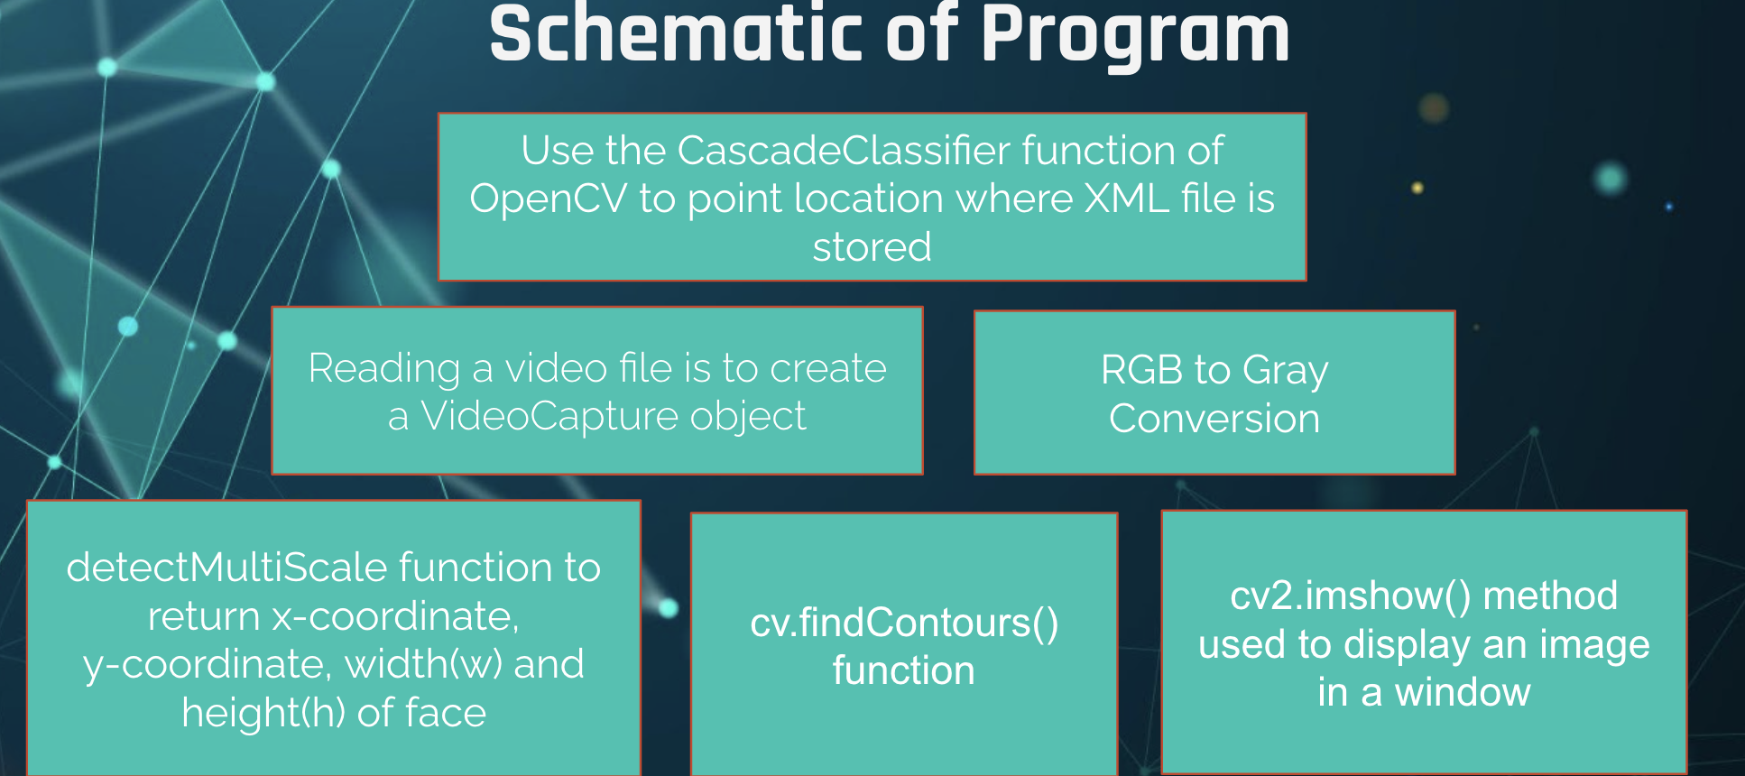

**EXPERIMENT**

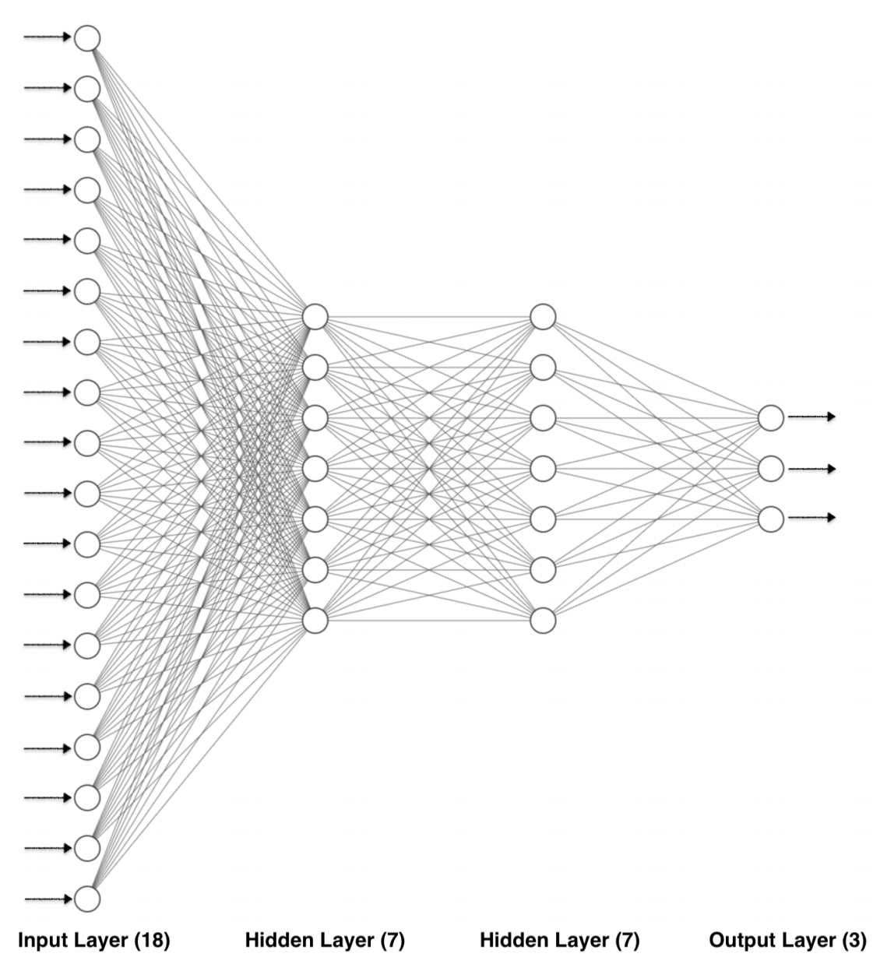

We are using two hidden layers, fourteen hidden neurons in the project. The output layer produces the final outcome of the analyzed data, it gives us a presentation of the figure

expression after deciphering. 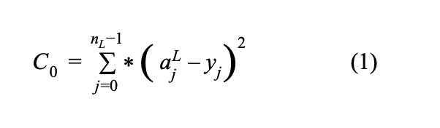

In order to understand machine learning better, we need to take a close look at equations used to calculate the weights and biases, they are used to contribute to calculate cost function. In order to figure out the weight differences, it is common to look from the back. With the help of tracing back, we would be able to change the weights in each level. The last neuron in the following functions is called a, with a superscript L. L is the letter that stands for the current layer. With the following layer aL-1 is the activation of the previous sheet. In order to calculate the difference, we use the number from the previous layer to subtract the current layer. Then the number we get is the cost. Of all the layers standing on a neural network, if we add the square of all the differences calculated in between layers. The formula (1) describes how the cost is computed as follows in a neural network.

**ANALYSIS**

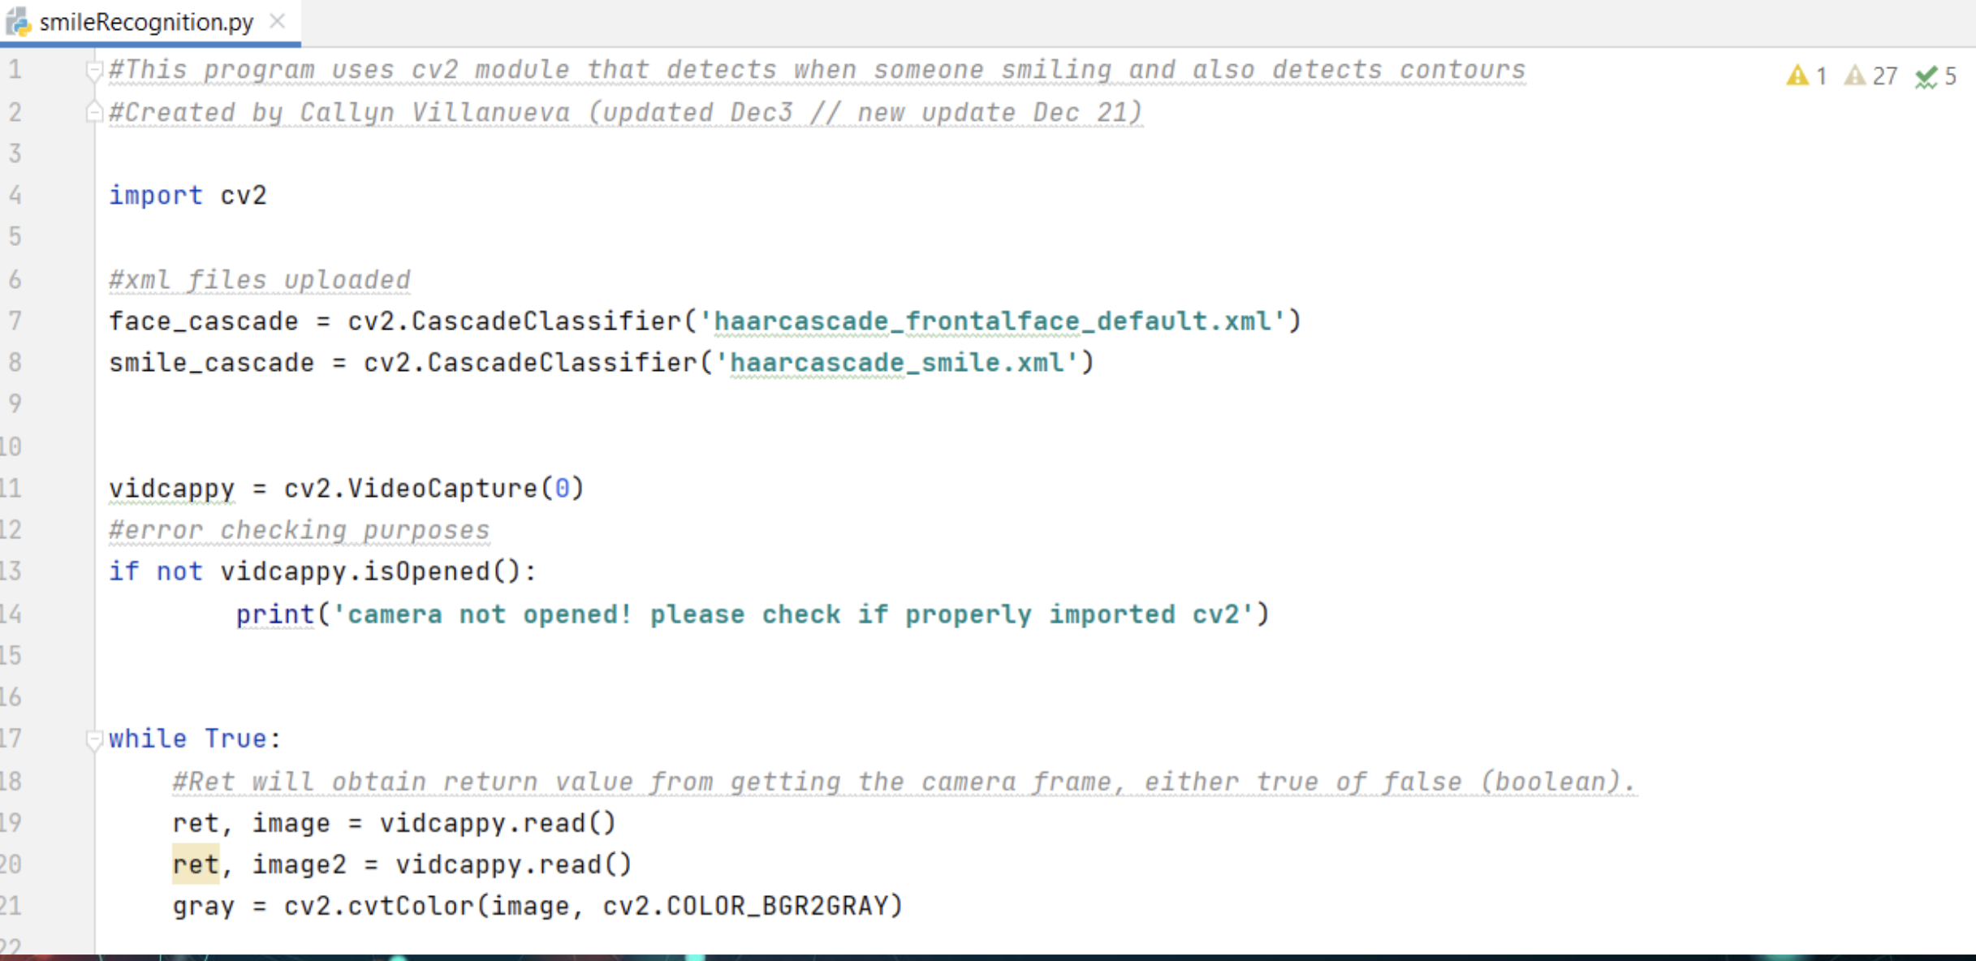

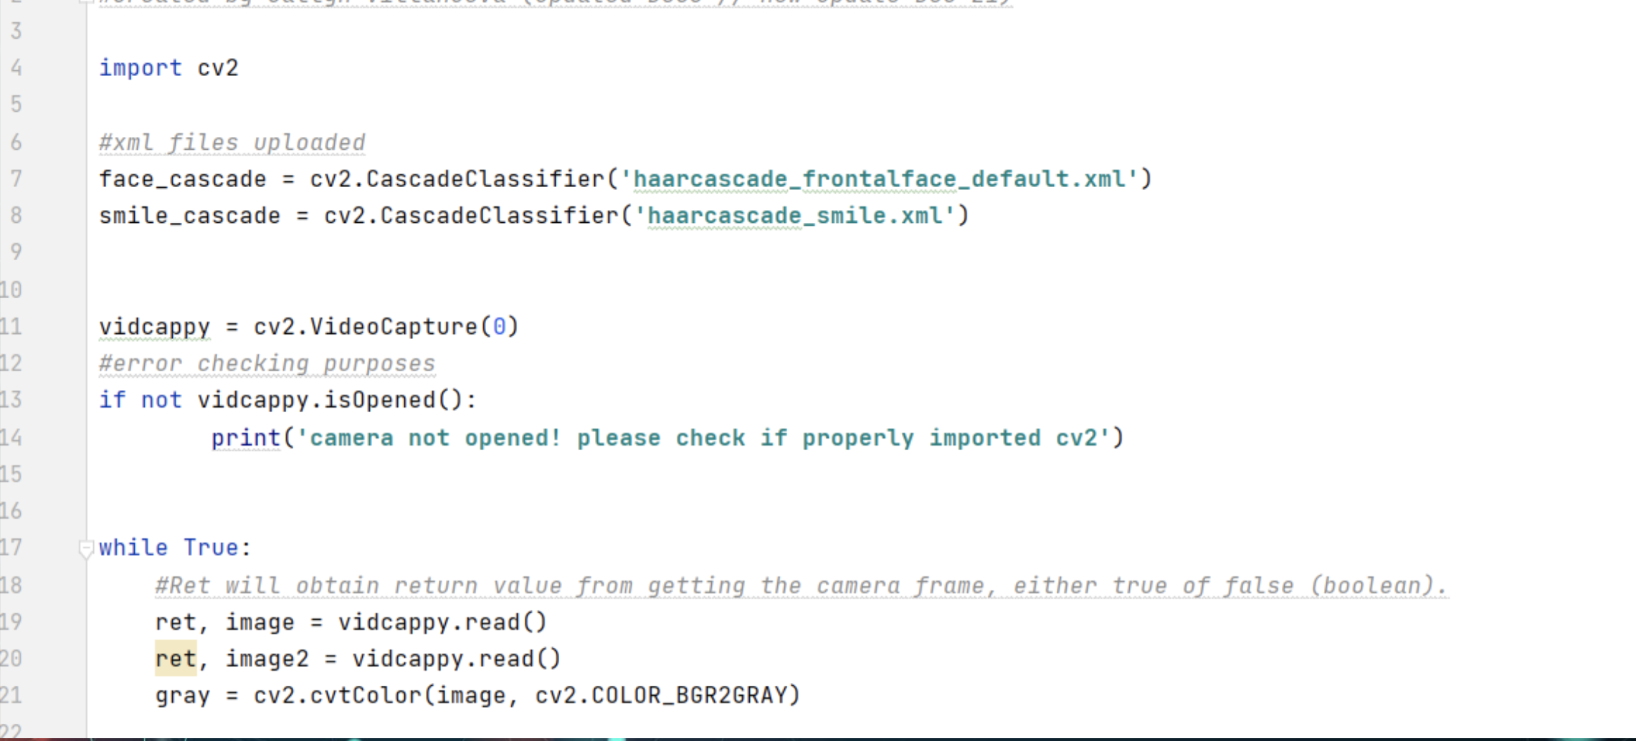

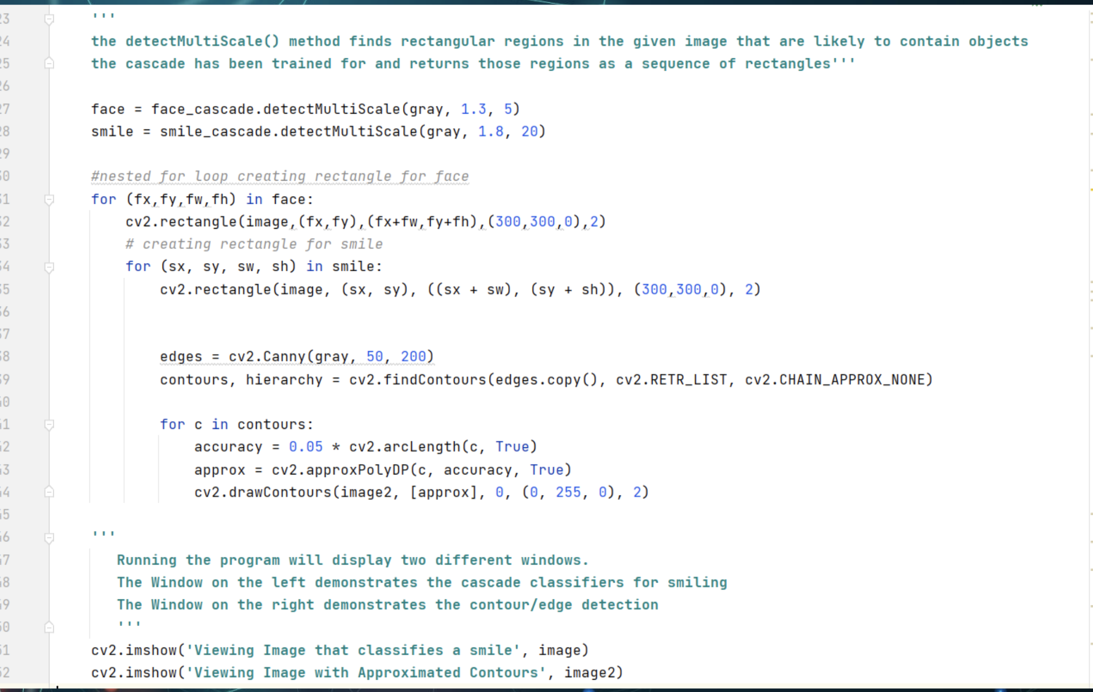

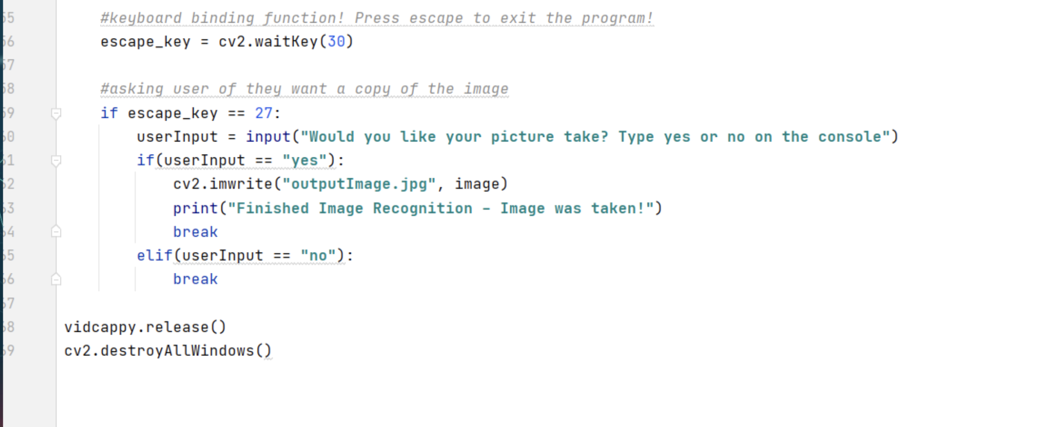

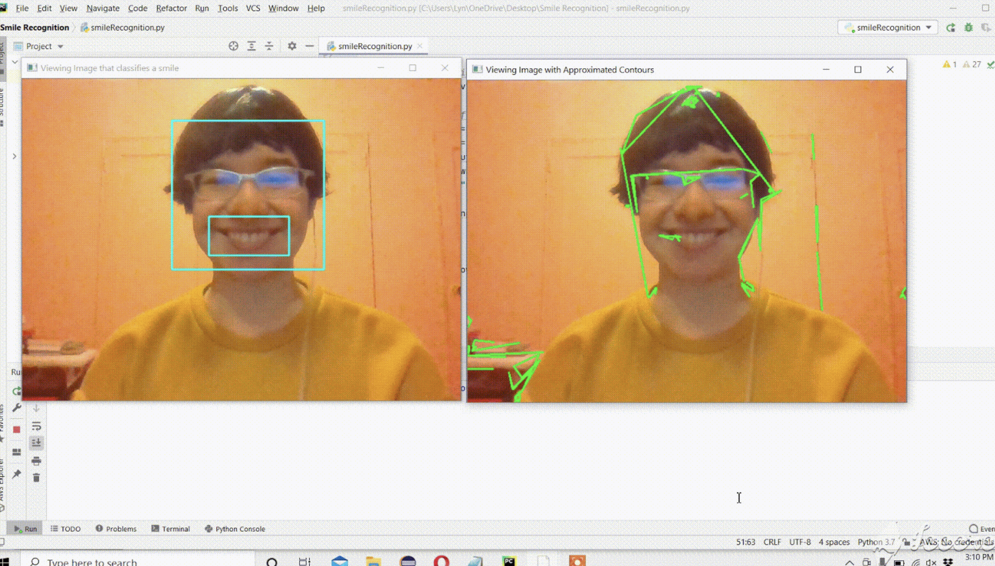

**CONCLUSION**

In order to figure out human emotions, we trained computers to study emotions. computers were trained to recognize different faces in order to tell the difference. After using machine learning, different emotions were easy to tell, such as anger, disgust, fear and sadness. We are hoping in the near future, computers are used more broadly to tell human emotions both in science related fields and real life. Computers made our life easier by telling different faces and what they mean. This can help us find the reason behind human expressions and decipher the mysterious code.

**REFERENCE**

[1] P. Viola and M. Jones, "Rapid object detection using a boosted cascade of simple features," Proceedings of the 2001 IEEE Computer Society Conference on Computer Vision and Pattern Recognition. CVPR 2001, Kauai, HI, USA, 2001, pp. I-I, doi: 10.1109/CVPR.2001.990517. Retrieved from: <https://ieeexplore-ieee-org.arktos.nyit.edu/stamp/stamp.jsp?tp=&arnumber=990517>

[2] J. Carroll and J. Russell. Do facial expressions signal specific emotions? Journal of Personality and Social Psychology., 70:205–218, 1996.

[3] Y. Wu and K. Toyama. Wide-range person and illumination-insensitive head orientation estimation. In Proceedings of International Conference on Automatic Face and Gesture Recognition, pages 183– 188, 2000.